# Chapter III: State of the Art

## Introduction

In today's digital era, the automation of repetitive tasks has become crucial for enhancing productivity and efficiency. Orchestration of automation processes refers to the coordination and management of automated tasks, ensuring that they run smoothly and efficiently. This chapter explores various methods of implementing automation, the role of AI in advancing automation scripts, and the rationale behind the chosen approach for this project.

## I. Methods of Implementing Automation

Automation methods range from basic scripting to advanced frameworks. Each approach offers unique benefits and applications in streamlining tasks and boosting efficiency.

### Scripting and Manual Automation

### Scripting and manual automation involve crafting commands or scripts to handle repetitive tasks directly. This approach is ideal for simple automation needs, particularly in system administration. While offering customization, it may lack the scalability of more comprehensive automation frameworks. Nonetheless, it's a fundamental skill in automation, these are some examples :

#### a. Shell Scripts

Shell scripts are a traditional method for automating tasks on Unix-based systems. They are simple to write and can automate command-line tasks, making them suitable for system administration and simple automation needs. However, shell scripts are limited in terms of flexibility and power compared to more modern scripting languages.

#### b. Python Scripts

Python has emerged as a popular language for automation due to its readability, versatility, and extensive library support. Python scripts can automate a wide range of tasks, from simple file manipulation to complex data processing and web scraping. Libraries such as smtplib for sending emails, requests for web interactions, and os for file operations enhance Python's capabilities in automation.

### Automation Frameworks and Tools

#### In the realm of automation, various frameworks and tools streamline processes efficiently. Here are some notable ones:

#### a. Ansible

Ansible is an open-source automation tool that enables configuration management, application deployment, and task automation. It uses YAML for configuration and can manage systems over SSH without requiring a client on the remote systems. Ansible's simplicity and agentless architecture make it a popular choice for IT automation.

#### e. UiPath

UiPath is a leading Robotic Process Automation (RPA) tool that allows businesses to automate repetitive tasks across various applications and systems. UiPath provides a user-friendly interface for designing automation workflows and integrates with numerous applications, making it a versatile tool for enterprise automation.

### 3. Robotic Process Automation (RPA)

Robotic Process Automation (RPA) revolutionizes automation by employing software robots to handle high-volume, repetitive tasks traditionally performed by humans. Key aspects include:

**Core Concepts:** RPA bots are designed to execute specific tasks, interacting with software systems and making decisions based on predefined rules.

**Integration:** RPA seamlessly integrates with existing enterprise applications, databases, and systems, making it suitable for automating legacy systems.

**Benefits:** RPA offers increased efficiency, cost savings, scalability, and improved accuracy, driving productivity gains and enhancing organizational performance.

**Challenges:** Implementation costs, change management, and maintenance are crucial considerations in adopting RPA solutions, requiring effective strategies for successful deployment and operation.

## II. Role of AI in Automation

Artificial Intelligence (AI) has transformed automation, enabling more sophisticated and intelligent solutions. Here, we explore AI's impact on automation, focusing on machine learning, AI-powered bots, and recent advancements.

1. **Machine Learning (ML) and Automation:** ML algorithms allow computers to learn from data, enhancing automation capabilities. Predictive analytics, anomaly detection, and process optimization are key applications of ML in automation.
2. **AI-Powered Bots:** AI-powered bots leverage NLP and ML to perform complex tasks, such as chatbots for customer inquiries and sentiment analysis for understanding customer feedback.
3. **Advances in AI for Automation:** Deep learning has revolutionized image and speech recognition, while reinforcement learning enables process optimization. Transfer learning accelerates AI development by reusing pre-trained models.
4. **AI in Specific Automation Scenarios:** Intelligent Process Automation (IPA) combines RPA with ML and NLP for more adaptive solutions. Cognitive automation simulates human thought processes, aiding decision support and knowledge management.

AI empowers automation by enabling systems to learn, adapt, and make intelligent decisions, leading to enhanced efficiency and productivity.

## III. Bot Development Overview

### Here, we introduce the selection and rationale behind the bots chosen for development in our project. These bots aim to streamline tasks through automation, enhancing efficiency and productivity.

### 1. Mail Sender Bot

The Mail Sender bot automates the process of sending emails. It takes the subject, body of the email, and recipient addresses from a configuration file and uses the smtplib library to send emails. This bot was developed to streamline email communications and reduce manual effort. The script ensures secure connections using the ssl module and handles potential errors such as incorrect email addresses or connection issues.

### 2. Chat Bot

The Chat Bot uses an API (<https://simple-chatgpt-api.p.rapidapi.com/ask>) to send questions from the configuration file and returns answers. This bot leverages AI to provide intelligent responses, making it suitable for customer support and information retrieval. The development involved integrating the API and handling JSON responses to extract meaningful answers. Error handling mechanisms were also implemented to manage API rate limits and potential downtime.

### 3. Log Analyzer

The Log Analyzer bot processes log files and counts the number of errors and warnings. It helps in monitoring and maintaining system health by providing insights into the frequency and types of issues occurring in the logs. The script reads log files, parses them, and uses regular expressions to identify and count error and warning messages. Additionally, it generates summary reports that can be used for further analysis.

### 4. Resume Reviewer

The Resume Reviewer bot uses the OpenAI API to evaluate resumes based on job descriptions and return a score out of 10. This bot assists HR departments in screening resumes more efficiently and objectively. The script sends resume and job description texts to the API and processes the response to generate a score. It also provides feedback on areas of improvement for the candidates, helping them enhance their resumes.

### 5. Text Summarizer

The Text Summarizer bot utilizes the OpenAI API to summarize text provided in the configuration file. This bot aids in quickly understanding large volumes of text by providing concise summaries. The development involved sending the text to the API, receiving the summary, and formatting it for presentation. This bot is particularly useful for processing lengthy documents and extracting key information.

## IV. Rationale Behind the Chosen Approach

Let's explore why we opted for standalone Python scripts as our automation approach. This section breaks down the simplicity, flexibility, and alignment with project goals that guided our decision-making process.

### 1. Simplicity and Flexibility

The chosen approach of using standalone Python scripts for automation was driven by the need for simplicity and flexibility. This section delves into why this approach was suitable for the project and how it meets various requirements.

#### a. Ease of Use

Python is renowned for its readability and simplicity, making it an ideal choice for rapid development and iteration. Its syntax is clear and concise, which reduces the learning curve for developers and allows for faster implementation of automation tasks.

* **Rapid Prototyping**: Python’s simplicity enables quick prototyping of automation scripts. Developers can quickly write, test, and refine scripts without getting bogged down by complex syntax or verbose code.
* **Minimal Overhead**: Using standalone Python scripts avoids the overhead associated with setting up and maintaining complex frameworks or environments. This allows the team to focus on the core functionality of the automation tasks.

#### b. Versatility

Python’s extensive standard library and third-party packages provide tools for almost any task, from web scraping to machine learning. This versatility is crucial for developing a wide range of bots.

* **Comprehensive Libraries**: Libraries such as requests for HTTP requests, smtplib for email handling, and re for regular expressions cover most automation needs without requiring additional tools.
* **Integration Capabilities**: Python’s ability to integrate with various APIs and external services makes it easy to extend the functionality of the bots. For instance, the integration with OpenAI API for NLP tasks and the Simple ChatGPT API for conversational bots.

### 2. Team Manager's Requirements

The project was also guided by specific requirements from the team manager, emphasizing a straightforward and practical solution.

#### a. Simplicity Over Complexity

The team manager prioritized a simple, easily maintainable solution over a more complex system. This decision was based on the need to deliver a functional product within a limited timeframe and ensure that it could be easily managed by the team.

* **Straightforward Implementation**: By choosing a straightforward approach, the team avoided the complexities and potential pitfalls of more sophisticated frameworks or tools that could have introduced unnecessary complexity.
* **Ease of Handoff**: Simpler solutions are easier to hand off to new team members or maintainers, ensuring continuity and ease of future modifications or extensions.

#### b. Resource Constraints

Considering the constraints on time, budget, and available resources, the chosen approach aligned well with the project’s scope.

* **Cost-Effective**: Utilizing Python scripts avoided the need for expensive software licenses or extensive infrastructure. Open-source libraries and tools further minimized costs.
* **Time Efficiency**: The team could focus on developing core functionalities without spending excessive time on configuring and learning new tools or frameworks.

### 3. Scalability and Maintainability

Using standalone Python scripts also offers advantages in terms of scalability and maintainability, which are crucial for the long-term success of the project.

#### a. Modular Design

The modular nature of Python scripts allows for easy addition, modification, and extension of functionality.

* **Adding New Bots**: New bots can be developed and added to the system without significant changes to the existing architecture. Each bot operates independently, reducing the risk of introducing bugs or conflicts.
* **Modifying Existing Bots**: Updates or changes to individual bots can be made with minimal impact on the overall system. This modular approach ensures that enhancements or fixes can be deployed quickly and efficiently.

#### b. Maintenance and Debugging

Python’s straightforward syntax and comprehensive error handling make maintenance and debugging more manageable.

* **Readable Code**: The readability of Python code simplifies the process of understanding and modifying scripts. Clear, well-documented code is easier to maintain and debug.
* **Robust Error Handling**: Python’s exception handling mechanisms allow for the graceful handling of errors, ensuring that the system remains robust and reliable.

#### c. Community and Support

Python has a large and active community, providing extensive resources for troubleshooting, learning, and extending capabilities.

* **Community Support**: The vast Python community offers forums, tutorials, and documentation that can assist in resolving issues and improving the bots.
* **Library Ecosystem**: The availability of numerous libraries and frameworks developed by the community can be leveraged to enhance the functionality of the bots without reinventing the wheel.

### 4. Alignment with Project Goals

The chosen approach aligns well with the overarching goals of the project, ensuring that it meets the requirements effectively and efficiently.

#### a. Functional Completeness

The approach ensures that all required functionalities are implemented and work as expected. Each bot performs its designated task effectively, contributing to the overall goal of automating various processes.

#### b. Timely Delivery

By adopting a straightforward and manageable approach, the team ensured that the project was completed within the allocated timeframe. This was crucial for meeting deadlines and delivering a functional product on schedule.

#### c. User-Friendly Interface

The simplicity of the backend implementation allowed the team to focus on creating a user-friendly interface. This ensures that both administrators and users can interact with the system easily, without requiring technical expertise.

## Conclusion

This chapter has explored the various methods of implementing automation, the impact of AI on automation processes, and the specific development and functionality of the bots in this project. The chosen approach of using Python scripts aligns with the project's goals of simplicity, flexibility, and meeting the team manager's requirements. By leveraging Python and AI, the project effectively orchestrates automation processes, enhancing productivity and efficiency.

**Sprint 2**

### I. Introduction

In Sprint 2 of our project, we focused on implementing features for managing bots and user activities. This included developing an admin interface for CRUD (Create, Read, Update, Delete) operations on bots and creating detailed activity logs for both admins and users.

* Global use case

### II. Sprint Backlog

For Sprint 2, the backlog consists of the following user stories and tasks:

|  |  |  |  |  |
| --- | --- | --- | --- | --- |
| Feature | Actor | User Story | Task Description | Priority |
| Manage Bots | Admin | |  | | --- | |  |  |  | | --- | | As an admin, I want to create new bots | | - Design bot creation form  - Implement backend API for bot creation  - Validate bot attributes  - Integrate form with backend | High |
| As an admin, I want to update existing bots | - Design bot update form  - Implement backend API for bot update  - Validate updates  - Integrate form with backend | High |
| As an admin, I want to delete bots | |  | | --- | | - Implement delete functionality in backend API  - Add delete option in admin interface  - Confirm deletion | | Medium |
| As an admin, I want to view a list of all bots | --Design list view for bots with pagination , search bar and a Search By option  - Implement backend API to fetch bots  - Display bots in admin interface | High |
| User | As a user, I want to view a list of all available bots based on my group | - Implement backend API to fetch bots based on user groups  - Display bots list in user interface with pagination , a search bar and a search by option  - Ensure correct group-based access | High |
| Manage Activities | Admin | As an admin, I want to view logs of all user activities, including bot starts, configurations used, and outcomes | - Implement backend API to fetch users activities  - Display activities list  - Add filtering options | Medium |
| User | As a user, I want to view my own activity logs to see when I started bots, the configurations used, and the outcomes | - Implement backend API to fetch the user activities  - Display activities list  - Add filtering options | High |
| As a user, I want to start a bot by uploading a configuration file | - Design bot execution form  - Implement backend API for bot execution  - Handle file uploads  - Validate and process configuration  -Start bot | High |
| As a user, I want to schedule a bot to start at a specific time | - Implement scheduling functionality in backend  - Design scheduling interface  - Validate scheduling input  - Integrate with backend | Medium |

### III. Conception

#### 1. Use Case Diagram

### A-Manage Bots

Refinement of the use case “Manage bots”

Top of Form

Bottom of Form

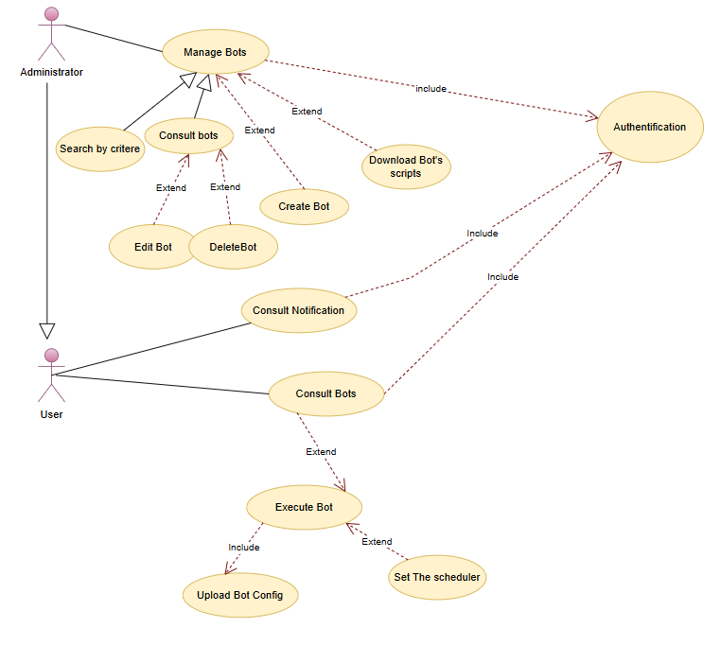

### Use Case Table: Common Actions (Admin and User)

|  |  |  |  |  |  |
| --- | --- | --- | --- | --- | --- |
| |  | | --- | | **Use Case** |  |  | | --- | |  | | | **Consult Bots** | | --- |  |  | | --- | |  | |
| |  | | --- | | **Actors** |  |  | | --- | |  | | |  | | --- | | Administrator, User |  |  | | --- | |  | |
| |  | | --- | | **Pre-Condition** |  |  | | --- | |  | | |  | | --- | | Actors must be authenticated. |  |  | | --- | |  | |
| |  | | --- | | **Post-Condition** |  |  | | --- | |  | | |  | | --- | | List of bots is displayed. |  |  | | --- | |  | |
| **Primary Scenario Description** | 1. The actor authenticates.  2. The actor navigates to the bots section.  3. The system retrieves and displays the list of available bots based on the actor's group. |
| **Exception Scenario** | 1. Authentication fails: The system prompts for re-authentication.  2. No bots available: The system displays a message indicating no bots are available for the user's group. |

|  |  |  |  |  |  |  |  |
| --- | --- | --- | --- | --- | --- | --- | --- |
| |  | | --- | | **Use Case** |  |  | | --- | |  | | |  |  |  | | --- | --- | --- | | | **Execute Bot** | | --- |  |  | | --- | |  | |  |  | | --- | |  | |
| |  | | --- | | **Actors** |  |  | | --- | |  | | |  | | --- | | Administrator, User |  |  | | --- | |  | |
| |  | | --- | | **Pre-Condition** |  |  | | --- | |  | | |  | | --- | | Actors must be authenticated. The bot configuration must be uploaded. |  |  | | --- | |  | |
| |  | | --- | | **Post-Condition** |  |  | | --- | |  | | |  |  |  | | --- | --- | --- | | |  | | --- | | Bot is executed and the result is logged. |  |  | | --- | |  | |  |  | | --- | |  | |
| **Primary Scenario Description** | 1. The actor authenticates  2. The actor consults the list of bots  3. The actor selects a bot to execute.  4. The actor uploads a bot configuration  5. The system executes the bot with the provided configuration  6. The system logs the execution result and displays it to the actor. |
| **Exception Scenario** | 1. Authentication fails: The system prompts for re-authentication.  2. Invalid configuration: The system shows an error message and prompts for correct configuration upload. |

|  |  |  |  |  |  |  |  |  |  |
| --- | --- | --- | --- | --- | --- | --- | --- | --- | --- |
| |  | | --- | | **Use Case** |  |  | | --- | |  | | |  |  |  |  |  | | --- | --- | --- | --- | --- | | |  |  |  | | --- | --- | --- | | | **Set the Scheduler** | | --- |  |  | | --- | |  | |  |  | | --- | |  | |  |  | | --- | |  | |
| |  | | --- | | **Actors** |  |  | | --- | |  | | |  | | --- | | Administrator, User |  |  | | --- | |  | |
| |  | | --- | | **Pre-Condition** |  |  | | --- | |  | | |  | | --- | | Actors must be authenticated. |  |  | | --- | |  | |
| |  | | --- | | **Post-Condition** |  |  | | --- | |  | | |  |  |  |  |  | | --- | --- | --- | --- | --- | | |  |  |  | | --- | --- | --- | | |  | | --- | | Bot is scheduled for execution at a specified time. |  |  | | --- | |  | |  |  | | --- | |  | |  |  | | --- | |  | |
| **Primary Scenario Description** | 1. The actor authenticates.  2. The actor consults the list of bots.  3. The actor selects a bot to schedule.  4. The actor sets the scheduling time.  5. The system saves the schedule and confirms the scheduling. |
| **Exception Scenario** | 1. Authentication fails: The system prompts for re-authentication.  2. Invalid scheduling time: The system shows an error message and prompts for correct scheduling time. |

|  |  |  |  |  |  |  |  |  |  |
| --- | --- | --- | --- | --- | --- | --- | --- | --- | --- |
| |  | | --- | | **Use Case** |  |  | | --- | |  | | |  |  |  |  |  | | --- | --- | --- | --- | --- | | |  |  |  | | --- | --- | --- | | | **Set the Scheduler** | | --- |  |  | | --- | |  | |  |  | | --- | |  | |  |  | | --- | |  | |
| |  | | --- | | **Actors** |  |  | | --- | |  | | |  | | --- | | Administrator, User |  |  | | --- | |  | |
| |  | | --- | | **Pre-Condition** |  |  | | --- | |  | | |  | | --- | | Actors must be authenticated. |  |  | | --- | |  | |
| |  | | --- | | **Post-Condition** |  |  | | --- | |  | | |  |  |  |  |  |  |  | | --- | --- | --- | --- | --- | --- | --- | | |  |  |  |  |  | | --- | --- | --- | --- | --- | | |  |  |  | | --- | --- | --- | | |  | | --- | | Notifications are displayed. |  |  | | --- | |  | |  |  | | --- | |  | |  |  | | --- | |  | |  |  | | --- | |  | |
| **Primary Scenario Description** | 1. The user authenticates.  2. The user navigates to the notifications section.  3. The system retrieves and displays the notifications for the user. |
| **Exception Scenario** | 1. Authentication fails: The system prompts for re-authentication.  2. No notifications: The system displays a message indicating no notifications. |

### Use Case Table: Administrator Actions

|  |  |  |  |  |  |  |  |  |  |  |  |
| --- | --- | --- | --- | --- | --- | --- | --- | --- | --- | --- | --- |
| |  | | --- | | **Use Case** |  |  | | --- | |  | | |  |  |  |  |  |  |  | | --- | --- | --- | --- | --- | --- | --- | | |  |  |  |  |  | | --- | --- | --- | --- | --- | | |  |  |  | | --- | --- | --- | | | **Create Bot** | | --- |  |  | | --- | |  | |  |  | | --- | |  | |  |  | | --- | |  | |  |  | | --- | |  | |
| |  | | --- | | **Actors** |  |  | | --- | |  | | |  | | --- | | Administrator |  |  | | --- | |  | |
| |  | | --- | | **Pre-Condition** |  |  | | --- | |  | | |  |  |  |  |  | | --- | --- | --- | --- | --- | | |  |  |  | | --- | --- | --- | | |  | | --- | | Administrator must be authenticated. |  |  | | --- | |  | |  |  | | --- | |  | |  |  | | --- | |  | |
| |  | | --- | | **Post-Condition** |  |  | | --- | |  | | |  |  |  |  |  |  |  | | --- | --- | --- | --- | --- | --- | --- | | |  |  |  |  |  | | --- | --- | --- | --- | --- | | |  |  |  | | --- | --- | --- | | |  | | --- | | New bot is created and available for use. |  |  | | --- | |  | |  |  | | --- | |  | |  |  | | --- | |  | |  |  | | --- | |  | |
| **Primary Scenario Description** | 1. The administrator authenticates.  2. The administrator navigates to the create bot section  3. The administrator fills in the bot details (name, description, script, guide, config type).  4. The system validates and saves the new bot.  5. The system confirms the creation and displays the new bot in the list. |
| **Exception Scenario** | 1. Authentication fails: The system prompts for re-authentication.  2. Invalid bot details: The system shows an error message and prompts for correct details. |

|  |  |  |  |
| --- | --- | --- | --- |
| |  | | --- | | **Use Case** |  |  | | --- | |  | | **Edit Bot** |
| |  | | --- | | **Actors** |  |  | | --- | |  | | |  | | --- | | Administrator |  |  | | --- | |  | |
| |  | | --- | | **Pre-Condition** |  |  | | --- | |  | | |  |  |  |  |  | | --- | --- | --- | --- | --- | | |  |  |  | | --- | --- | --- | | |  | | --- | | Administrator must be authenticated. |  |  | | --- | |  | |  |  | | --- | |  | |  |  | | --- | |  | |
| |  | | --- | | **Post-Condition** |  |  | | --- | |  | | |  |  |  |  |  |  |  |  |  | | --- | --- | --- | --- | --- | --- | --- | --- | --- | | |  |  |  |  |  |  |  | | --- | --- | --- | --- | --- | --- | --- | | |  |  |  |  |  | | --- | --- | --- | --- | --- | | |  |  |  | | --- | --- | --- | | |  | | --- | | Bot details are updated. |  |  | | --- | |  | |  |  | | --- | |  | |  |  | | --- | |  | |  |  | | --- | |  | |  |  | | --- | |  | |
| **Primary Scenario Description** | 1. The administrator authenticates.  2. The administrator navigates to the edit bot section.  3. The administrator selects a bot to edit.  4. The administrator updates the bot details.  5. The system validates and saves the updated details.  6. The system confirms the update and displays the updated bot in the list. |
| **Exception Scenario** | 1. Authentication fails: The system prompts for re-authentication.  2. Invalid bot details: The system shows an error message and prompts for correct details. |

|  |  |  |  |
| --- | --- | --- | --- |
| |  | | --- | | **Use Case** |  |  | | --- | |  | | **Edit Bot** |
| |  | | --- | | **Actors** |  |  | | --- | |  | | |  | | --- | | Administrator |  |  | | --- | |  | |
| |  | | --- | | **Pre-Condition** |  |  | | --- | |  | | |  |  |  |  |  | | --- | --- | --- | --- | --- | | |  |  |  | | --- | --- | --- | | |  | | --- | | Administrator must be authenticated. |  |  | | --- | |  | |  |  | | --- | |  | |  |  | | --- | |  | |
| |  | | --- | | **Post-Condition** |  |  | | --- | |  | | |  |  |  |  |  |  |  |  |  | | --- | --- | --- | --- | --- | --- | --- | --- | --- | | |  |  |  |  |  |  |  | | --- | --- | --- | --- | --- | --- | --- | | |  |  |  |  |  | | --- | --- | --- | --- | --- | | |  |  |  |  | | --- | --- | --- | --- | | |  |  | | --- | --- | | |  | | --- | |  | |  |  | | --- | |  | |   Bot is deleted and no longer available for use. |  |  | | --- | |  | |  |  | | --- | |  | |  |  | | --- | |  | |
| **Primary Scenario Description** | 1. The administrator authenticates.  2. The administrator navigates to the delete bot section.  3. The administrator selects a bot to delete.  4. The system confirms the deletion.  5. The system removes the bot from the list. |
| **Exception Scenario** | 1. Authentication fails: The system prompts for re-authentication.  2. Deletion fails: The system shows an error message and prompts for retry. |

B-Manage Activities

Refinement of the use case “Manage Activites”

|  |  |  |  |  |  |
| --- | --- | --- | --- | --- | --- |
| |  | | --- | | **Use Case** |  |  | | --- | |  | | | **Consult Activities** | | --- |  |  | | --- | |  | |
| |  | | --- | | **Actors** |  |  | | --- | |  | | |  | | --- | | Administrator, User |  |  | | --- | |  | |
| |  | | --- | | **Pre-Condition** |  |  | | --- | |  | | |  | | --- | | Actors must be authenticated. |  |  | | --- | |  | |
| |  | | --- | | **Post-Condition** |  |  | | --- | |  | | |  | | --- | | List of Activities is displayed. |  |  | | --- | |  | |
| **Primary Scenario Description** | 1. The actor authenticates.  2. The actor navigates to the activity section.  3. The system retrieves the user's activity and displays it in a list where the user can view his bot’s executions details and their logs  4. The user can view the logs and config of every activity. |
| **Exception Scenario** | 1. Authentication fails: The system prompts for re-authentication.  2. No activity available: The system displays a message indicating no activities are available for the user. |

|  |  |  |  |  |  |
| --- | --- | --- | --- | --- | --- |
| |  | | --- | | **Use Case** |  |  | | --- | |  | | | **Consult Activities** | | --- |  |  | | --- | |  | |
| |  | | --- | | **Actors** |  |  | | --- | |  | | |  | | --- | | Administrator |  |  | | --- | |  | |
| |  | | --- | | **Pre-Condition** |  |  | | --- | |  | | |  | | --- | | Administrator must be authenticated. |  |  | | --- | |  | |
| |  | | --- | | **Post-Condition** |  |  | | --- | |  | | |  | | --- | | List of All users’s Activities is displayed. |  |  | | --- | |  | |
| **Primary Scenario Description** | 1. The administrator authenticates.  2. The administrator navigates to the activity section.  3. The system retrieves the activities of every user and displays it in a list.  4.The admin can view the logs and config of each activity. |
| **Exception Scenario** | 1. Authentication fails: The system prompts for re-authentication.  2. No activity available: The system displays a message indicating no activities are available. |

1. **Sequence Diagram**

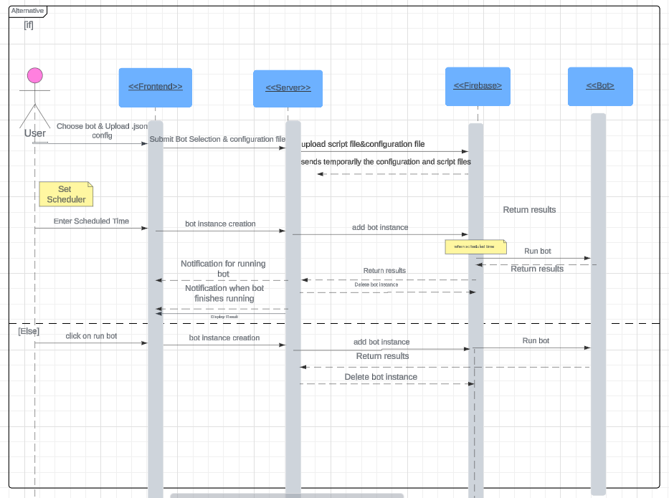

**IV-Development of the Project’s Bots**

In this section, I'll outline the development process of our bots, highlighting the key steps and technologies involved in bringing them to life.

### 1. Mail Sender Bot

The Mail Sender bot automates the process of sending emails, simplifying communication tasks. Here’s a detailed breakdown of its development:

#### a. Functionality

* **Input**: The bot receives a configuration file containing the subject, body of the email, and recipient addresses.
* **Process**: It uses the smtplib library to connect to an SMTP server and send emails.
* **Output**: Emails are sent to the specified recipients.

#### b. Implementation Details

* **Reading Configuration**: The bot reads a JSON configuration file using the json library. This file includes the email subject, body, sender credentials, and recipient list.
* **SMTP Setup**: Using smtplib, the bot establishes a secure connection to the SMTP server. It uses the ssl module to wrap the connection in a secure socket layer.
* **Sending Emails**: The bot iterates through the recipient list, sending personalized emails. It handles exceptions such as connection errors or incorrect email formats using try-except blocks.

### 2. Chat Bot

The Chat Bot leverages an external API to provide intelligent responses based on user queries. Here’s an in-depth look at its development:

#### a. Functionality

* **Input**: A configuration file containing a list of questions.
* **Process**: The bot sends these questions to the simple ChatGPT API and retrieves responses.
* **Output**: The bot returns the responses for display or further processing.

#### b. Implementation Details

* **API Integration**: The bot uses the requests library to interact with the Simple ChatGPT API. It sends HTTP requests with the questions and handles the responses.
* **Configuration Parsing**: The bot reads the configuration file to extract questions, using json for parsing.
* **Response Handling**: After receiving responses from the API, the bot processes the JSON data to extract the answers.

### 3. Log Analyzer

The Log Analyzer bot automates the process of analyzing log files, identifying errors and warnings. Here’s a detailed breakdown:

#### a. Functionality

* **Input**: Log files to be analyzed.
* **Process**: The bot reads and parses these log files, counting occurrences of errors and warnings.
* **Output**: A summary report detailing the number of errors and warnings.

#### b. Implementation Details

* **Reading the Log File:** The bot opens the specified log file and goes through its content line by line.
* **Counting Errors and Warnings:** As it reads each line, the bot looks for specific words, 'Error' and 'Warning'. Each time it finds 'Error', it increases the error count by one. Similarly, each time it finds 'Warning', it increases the warning count by one.
* **Generating the Report:** After it has read all the lines in the log file, the bot prepares a summary report. This report includes the total number of errors and warnings found.
* **Command-Line Interface:** The bot can be run from the command line. When running the bot, you need to provide the path to the log file you want to analyze. If you don't provide a log file path, the bot will show a message explaining how to use it. When a log file is provided, the bot analyzes it and then prints out the summary report in a structured format.

### 4. Resume Reviewer

The Resume Reviewer bot uses the OpenAI API to evaluate resumes based on job descriptions, providing a score and feedback. Here’s an in-depth look:

#### a. Functionality

* **Input**: A configuration file containing the resume.
* **Process**: The bot sends the resume and the job description to the OpenAI API for analysis.
* **Output**: A score out of 10 and detailed feedback on the resume.

#### b. Implementation Details

* **API Integration**: The bot uses the requests library to interact with the OpenAI API. It sends the resume and job description texts and processes the response.
* **Configuration Parsing**: The bot reads the input texts from a configuration file using the json library.
* **Response Processing**: The bot extracts the score and feedback from the API response and formats it for presentation.

#### c. Error Handling and Customization

* **Error Handling**: The bot includes mechanisms to handle API errors, network issues, and unexpected responses.
* **Customization**: Parameters like scoring criteria and feedback verbosity can be customized to meet specific requirements.

### 5. Text Summarizer

The Text Summarizer bot leverages the OpenAI API to generate concise summaries of input texts. Here’s a detailed breakdown:

#### a. Functionality

* **Input**: A configuration file containing the text to be summarized.
* **Process**: The bot sends the text to the OpenAI API and retrieves the summary.
* **Output**: A concise summary of the input text.

#### b. Implementation Details

* **API Integration**: The bot uses the requests library to send the input text to the OpenAI API and retrieve the summary.
* **Configuration Parsing**: The bot reads the text from a configuration file using the json library.
* **Response Handling**: The bot processes the API response to extract and format the summary for display or further use.

#### c. Enhancements and Extensions

* **Custom Summary Length**: The bot allows customization of summary length based on user requirements.
* **Multi-Document Summarization**: Future enhancements could include the ability to summarize multiple documents and compile a comprehensive summary.

**V-Realization**

1-Executing the scripts

In the realization phase, executing Python scripts from a Node.js environment involved a series of steps to seamlessly integrate the functionality of our bots. Here's a detailed breakdown of the process:

1. **Bot Instance Creation:** When a user initiates a bot, the server creates a botInstance document containing essential details such as the bot's ID, the user who initiated it, the URL of the configuration file (stored in Firebase), and if applicable, the scheduled execution time , then calls the RunBot function.

1. **Downloading Files:** Next, the server downloads the Python script and configuration file from Firebase to the local machine. This step ensures that the latest versions of the script and configuration are used for execution.

**3.Script Execution:** With the files downloaded, the server executes the Python script using the command *python ${scriptPath} ${configFilePath}*. This is the most crucial step in the process, ensuring that the script is executed with the appropriate configuration settings. The command initiates the script, passing the configuration file as an argument, enabling the script to access necessary parameters and run correctly.

1. **File Cleanup:** Once the script execution is complete, the server deletes the Python script and configuration file from the local machine to free up resources and maintain system cleanliness. However, the files remain stored in Firebase for future use.

1. **Awaiting Response:** Finally, the server awaits the response from the executed script, which contains the desired output or result. This response is then returned to the client-side application for further processing or display.

2-Manage Bots

-Admin can view the list of bots ,he can also search by name and description

-Admin can create a new Bot

-Admin can delete/Edit Bots

-User can start a bot

-user can also schedule a date for a bot to start

-User can view his Activities in the Activity tab

-user can view the logs of each execution

**Conclusion**

In this chapter, we have presented the development of the second sprint, including its design and certain application interfaces. In the next chapter, we will present the third sprint, which includes messages, notifications, and statistics.